# Regional Trading Blocs

What are Regional Trading Blocs?

A regional trading bloc (RTB) is a co-operative union or group of countries within a specific geographical boundary. RTB protects its member nations within that region from imports from the non-members. Trading blocs are a special type of economic integration. There are **four** types of trading blocs −

* **Preferential Trade Area** − Preferential Trade Areas (PTAs), the first step towards making a full-fledged RTB, exist when countries of a particular geographical region agree to decrease or eliminate tariffs on selected goods and services imported from other members of the area.
* **Free Trade Area** − Free Trade Areas (FTAs) are like PTAs but in FTAs, the participating countries agree to remove or reduce barriers to trade on all goods coming from the participating members.
* **Customs Union** − A customs union has no tariff barriers between members, plus they agree to a common (unified) external tariff against non-members. Effectively, the members are allowed to negotiate as a single bloc with third parties, including other trading blocs, or with the WTO.
* **Common Market** − A ‘common market’ is an exclusive economic integration. The member countries trade freely all types of economic resources – not just tangible goods. All barriers to trade in goods, services, capital, and labor are removed in common markets. In addition to tariffs, non-tariff barriers are also diminished or removed in common markets.

Regional Trading Blocs – Advantages

The advantages of having a Regional Trading Bloc are as follows −

* **Foreign Direct Investment** − Foreign direct investment (FDI) surges in TRBs and it benefits the economies of participating nations.
* **Economies of Scale** − The larger markets created results in lower costs due to mass manufacturing of products locally. These markets form economies of scale.
* **Competition** − Trade blocs bring manufacturers from various economies, resulting in greater competition. The competition promotes efficiency within firms.
* **Trade Effects** − As tariffs are removed, the cost of imports goes down. Demand changes and consumers become the king.
* **Market Efficiency** − The increased consumption, the changes in demand, and a greater amount of products result in an efficient market.

Regional Trading Blocs – Disadvantages

The disadvantages of having a Regional Trading Bloc are as follows −

* **Regionalism** − Trading blocs have bias in favor of their member countries. These economies establish tariffs and quotas that protect intra-regional trade from outside forces. Rather than following the World Trade Organization, regional trade bloc countries participate in regionalism.
* **Loss of Sovereignty** − A trading bloc, particularly when it becomes a political union, leads to partial loss of sovereignty of the member nations.
* **Concessions** − The RTB countries want to let non-member firms gain domestic market access only after levying taxes. Countries that join a trading bloc needs to make some concessions.
* **Interdependence** − The countries of a bloc become interdependent on each other. A natural disaster, conflict, or revolution in one country may have adverse effect on the economies of all participants.

There are four major trade blocs in current times that have the reputation and will to make a significant impact on international business process.

## ASEAN

Association of Southeast Asian Nations (ASEAN) was established on August 8, 1967, in Bangkok (Thailand).

* **Members** − The member states are Brunei Darussalam, Cambodia, Indonesia, Laos, Malaysia, Myanmar, Philippines, Singapore, Thailand, and Vietnam.
* **Goals** − The goals of ASEAN are to (a) accelerate economic growth, social progress, and cultural development in the region and (b) promote regional peace and stability and adhere to United Nations Charter.
* **ASEAN Economic Community (AEC)** − The AEC is aiming to transform ASEAN into a single entity and a production powerhouse that is highly competitive and fully compatible with the global economy.

## EU

The European Union (EU) was founded in 1951 by six neighboring states as the European Coal and Steel Community (ECSC). Over time, it became the European Economic Community (EEC), then the European Community (EC), and was ultimately transformed into the European Union (EU). EU is the single regional bloc with the largest number of member states (28).

* **Members** − Austria, Belgium, Bulgaria, Croatia, Cyprus, Czech Republic, Denmark, Estonia, Finland, France, Germany, Greece, Hungary, Ireland, Italy, Latvia, Lithuania, Luxembourg, Malta, Poland, Portugal, Romania, Slovakia, Slovenia, Spain, Sweden, The Netherlands, and the United Kingdom.
* **Goal of EU** − To construct a regional free-trade association of states through the union of political, economic, and executive connections.

## MERCOSUR

Mercado Comun del Cono Sur (MERCOSUR) was established on 26 March 1991 with the Treaty of Assunción. The major languages spoken in this region are Spanish and Portugese.

* **Members** − Argentina, Brazil, Paraguay, Uruguay, and Venezuela. Bolivia is undergoing the process of becoming a full member. Associate members include Chile, Colombia, Ecuador, Guyana, Peru, and Suriname. There are associate members who can do preferential trade but not allowed to have tariff benefits like the registered members. Mexico has an observer status.
* **Goals** − Accelerate sustained economic development based on social justice, environmental protection, and reduction of poverty.

## NAFTA

The North American Free Trade Agreement (NAFTA) was signed on 1 January 1994.

* **Members** − Canada, Mexico, and the United States of America.
* **Goals** − The goals of NAFTA are to (a) eliminate trade barriers among its member states, (b) promote an environment for free trade, (c) increase investment opportunities, and (d) protect intellectual property rights.

# Strategic Compulsions

To survive in the world of cut-throat competition, companies must sell their products in the global market. It is necessary to come up with new strategies to win more customers. Effective strategic management requires strategic estimation, planning, application and review/control.

The path for strategic management is activated by compulsions like modern developments in the societal and economic theory and the recent changes in the form of business, apart from the economic context.



Areas of Strategic Compulsions

Here is a list of some compulsions that a global business might have to face −

* **E-commerce and Internet Culture** − Expansion of internet and information technology made the business move towards e-commerce. Online shopping /Selling and Advertising are important issues. These factors compel the businesses to go modern.
* **Hyperactive Competition** − Businesses now are hyper-competitive which compel them to draw a competitive strategy that includes general competitive intelligence to win the market share.
* **Diversification** − Uncertainty and operational risks have increased in the current global markets. Companies now need to protect themselves by diversifying their products and operations. Businesses now are compelled to focus on more than one business, or get specialized in one business.
* **Active Pressure Groups** − Contemporary pressure groups direct businesses to be more ethical in their operations. Most of the multinationals are now spending a good deal to address their Corporate Social Responsibility (CSR).

Standardization Vs Differentiation

Standardization and differentiation are the two sides of globalization. By standardization, we mean to show the global representation, while differentiation looks upon local competitiveness. The following figure depicts how standardization differs from differentiation.

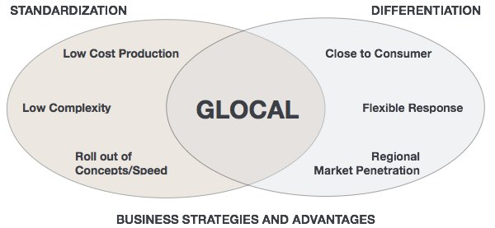

Strategic Options

Strategic Options include a set of strategies that helps a company in achieving its organizational goals. It is important to do a SWOT analysis of the internal environment and also the external environment to get the a list of possible strategic alternatives.

A business can’t run on gut feeling and hence, strategic options are indispensable tools for every international business manager. The following diagram shows the very basic options to choose – whether to go global or act local while improving the business in a holistic manner.

# Global Portfolio Management

**Global Portfolio Management,** also known as **International Portfolio Management** or **Foreign Portfolio Management,** refers to grouping of investment assets from international or foreign markets rather than from the domestic ones. The asset grouping in GPM mainly focuses on securities. The most common examples of Global Portfolio Management are −

* Share purchase of a foreign company
* Buying bonds that are issued by a foreign government
* Acquiring assets in a foreign firm

## Factors Affecting Global Portfolio Investment

Global Portfolio Management (GPM) requires an acute understanding of the market in which investment is to be made. The major financial factors of the foreign country are the factors affecting GPM. The following are the most important factors that influence GPM decisions.



### Tax Rates

Tax rates on dividends and interest earned is a major influencer of GPM. Investors usually choose to invest in a country where the applied taxes on the interest earned or dividend acquired is low. Investors normally calculate the potential after-tax earnings they will secure from an investment made in foreign securities.

### Interest Rates

High interest rates are always a big attraction for investors. Money usually flows to countries that have high interest rates. However, the local currencies must not weaken for long-term as well.

### Exchange Rates

When investors invest in securities in an international country, their return is mostly affected by −

* The apparent change in the value of the security.
* The fluctuations in the value of currency in which security is managed.

Investors usually shift their investment when the value of currency in a nation they invest weakens more than anticipated.

## Modes of Global Portfolio Management

Foreign securities or depository receipts can be bought directly from a particular country’s stock exchange. Two concepts are important here which can be categorized as **Portfolio Equity** and **Portfolio Bonds**. These are supposed to be the best modes of GPM. A brief explanation is provided hereunder.

### Portfolio Equity

Portfolio equity includes net inflows from equity securities other than those recorded as direct investment and including shares, stocks, depository receipts (American or global), and direct purchases of shares in local stock markets by foreign investors.

### Portfolio Bonds

Bonds are normally medium to long-term investments. Investment in Portfolio Bond might be appropriate for you if −

* You have additional funds to invest.
* You seek income, growth potential, or a combination of the two.
* You don’t mind locking your investment for five years, ideally longer.
* You are ready to take some risk with your money.
* You are a taxpayer of basic, higher, or additional-rate category.

### Global Mutual Funds

Global mutual funds can be a preferred mode if the Investor wants to buy the shares of an internationally diversified mutual fund. In fact, it is helpful if there are open-ended mutual funds available for investment.

### Closed-end Country Funds

Closed-end funds invest in internationals securities against the portfolio. This is helpful because the interest rates may be higher, making it more profitable to earn money in that particular country. It is an indirect way of investing in a global economy. However, in such investments, the investor does not have ample scope for reaping the benefits of diversification, because the systematic risks are not reducible to that extent.

## Drawbacks of Global Portfolio Management

Global Portfolio Management has its share of drawbacks too. The most important ones are listed below.

* **Unfavorable Exchange Rate Movement** − Investors are unable to ignore the probability of exchange rate changes in a foreign country. This is beyond the control of the investors. These changes greatly influence the total value of foreign portfolio and the earnings from the investment. The weakening of currency reduces the value of securities as well.
* **Frictions in International Financial Market** − There may be various kinds of market frictions in a foreign economy. These frictions may result from Governmental control, changing tax laws, and explicit or implicit transaction costs. The fact is governments actively seek to administer international financial flows. To do this, they use different forms of control mechanisms such as taxes on international flows of FDI and applied restrictions on the outflow of funds.
* **Manipulation of Security Prices** − Government and powerful brokers can influence the security prices. Governments can heavily influence the prices by modifying their monetary and fiscal policies. Moreover, public sector institutions and banks swallow a big share of securities traded on stock exchanges.
* **Unequal Access to Information** − Wide cross-cultural differences may be a barrier to GPM. It is difficult to disseminate and acquire the information by the international investors beforeha

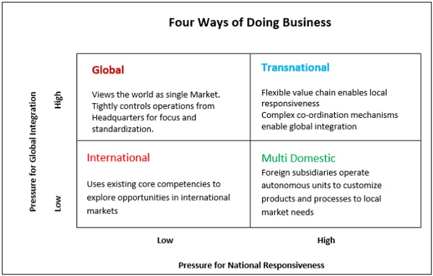

Factors that Affect Strategic Options

There are many factors that need to be taken care of while choosing the best possible strategic options. The most influential ones are the following −

* **External Constraints** − The survival and prosperity of a business firm is fully dependent on interaction and communication with the elements that are intrinsic to the business. It includes the owners, customers, suppliers, competitors, government, and the stakeholders of the community.
* **Intra-organizational Forces** − The big decisions of a company are often influenced by the power-play among various interest groups. The strategic decision-making processes are no exception. It depends on the strategic choices made by the lower Management and top notch strategic management people.
* **Values and Preferences towards Risk** − Values play a very important role, It has been observed hat the successful managers have a more pragmatic, interactive and dynamic progressive and achievement seeking values. The risk takers in the high-growth less-stable markets prefer to be the pioneers or innovators. They seek an early entry into new, untapped markets.
* **Impact of Past Strategies** − A strategy made earlier may affect the current strategy too. Past strategies are the starting point of building up a new strategies
* **Time Constraints** − There may be deadlines to be met. There may be a period of commitment, which would require a company to take immediate action.
* **Information Constraints** − The choice of a strategy depends heavily on the availability of information. A company can deal with uncertainty and risks depending on the availability of information at its disposal. Lesser the amount of information, greater the probability of risks.
* **Competitor’s Risk** − It is important to weigh the strategic choices the competitors may have. A competitor who adopts a counter-strategy must be taken into account by the management. The likelihood of a competitor’s strength to react and its probable impact will influence the strategic choices.

# Modes of Entry

The long-term advantages of doing international business in a particular country depend upon the following factors −

* Size of the market demographically
* The purchasing power of the consumers in that market
* Nature of competition

By considering the above-mentioned factors, firms can rank countries in terms of their attractiveness and profitability. The **timing of entry** into a nation is a very important factor. If a firm enters the market ahead of other firms, it may quickly develop a strong customer base for its products.

There are seven major modes of entering an international market. In this chapter, we will take up each mode and discuss their advantages and disadvantages.

Exporting

An item produced in a domestic market can be sold abroad. Storing and processing is mainly done in the supplying firm’s home country. Export can increase the sales volume. When a firm receives canvassed items and exports them, it is called **Passive Export**.

Alternately, if a strategic decision is taken to establish proper processes for organizing the export functions and for obtaining foreign sales, it is known as **Active Export**.

* **Advantages** − Low investment; Less risks
* **Disadvantages** − Unknown market; No control over foreign market; Lack of information about external environment

Licensing

In this mode of entry, the manufacturer of the home country leases the right of intellectual properties, i.e., technology, copyrights, brand name, etc., to a manufacturer of a foreign country for a predetermined fee. The manufacturer that leases is known as the **licensor** and the manufacturer of the country that gets the license id known as the **licensee**.

* **Advantages** − Low investment of licensor; Low financial risk of licensor; Licensor can investigate the foreign market; Licensee’s investment in R&D is low; Licensee does not bear the risk of product failure; Any international location can be chosen to enjoy the advantages; No obligations of ownership, managerial decisions, investment etc.
* **Disadvantages** − Limited opportunities for both parties involved; Both parties have to manage product quality and promotion; One party’s dishonesty can affect the other; Chances of misunderstanding; Chances of trade secrets leakage of the licensor.

Franchising

In this mode, an independent firm called the **franchisee** does the business using the name of another company called the **franchisor**. In franchising, the franchisee has to pay a fee or a fraction of profit to the franchisor. The franchisor provides the trademarks, operating process, product reputation and marketing, HR and operational support to the franchisee.

**Note** − The Entrepreneur magazine’s top ranker in "The 2015 Franchise 500" is Hampton Hotels. It has 2,000 hotels in 16 countries.

* **Advantages** − Low investment; Low risk; Franchisor understands market culture, customs and environment of the host country; Franchisor learns more from the experience of the franchisees; Franchisee gets the R&D and brand name with low cost; Franchisee has no risk of product failure.
* **Disadvantages** − Franchising can be complicated at times; Difficult to control; Reduced market opportunities for both franchisee and franchisor; Responsibilities of managing product quality and product promotion for both; Leakage of trade secrets

Turnkey Project

It is a special mode of carrying out international business. It is a contract under which a firm agrees – for a remuneration – to fully carry out the design, create, and equip the production facility and shift the project over to the purchaser when the facility is operational.

Mergers & Acquisitions

In Mergers & Acquisitions, a home company may merge itself with a foreign company to enter an international business. Alternatively, the home company may buy a foreign company and acquire the foreign company’s ownership and control. M&A offers quick access to international manufacturing facilities and marketing networks.

* **Advantages** − Immediate ownership and control over the acquired firm’s assets; Probability of earning more revenues; The host country may benefit by escaping optimum capacity level or overcapacity level
* **Disadvantages** − Complex process and requires experts from both countries; No addition of capacity to the industry; Government restrictions on acquisition of local companies may disrupt business; Transfer of problems of the host country’s to the acquired company.

Joint Venture

When two or more firms join together to create a new business entity, it is called a **joint venture**. The uniqueness in a joint venture is its shared ownership. Environmental factors like social, technological, economic and political environments may encourage joint ventures.

* **Advantages** − Joint ventures provide significant funds for major projects; Sharing of risks between or among partners; Provides skills, technology, expertise, marketing to both parties.
* **Disadvantages** − Conflicts may develop; Delay in decision-making of one affects the other party and it may be costly; The venture may collapse due to the entry of competitors and the changes in the partner’s strength; Slow decision-making due to the involvement of two or more decision-makers.

Wholly Owned Subsidiary

Wholly Owned Subsidiary is a company whose common stock is fully owned by another company, known as the **parent company**. A wholly owned subsidiary may arise through acquisition or by a spin-off from the parent company.

# Organizational Structures

Every international business firm has to face various issues related to organizational policies. These organizational issues are to be addressed carefully in order to keep the business healthy and profitable. Although there are numerous issues, both small and big, we will primarily concentrate only on the major issues that need to be addressed.

## Centralization vs. Decentralization

**Centralization** is the systematic and consistent reservation of authority at central points in the organization. In **centralization,** the decision-making capability lies with a few selected employees. The implications of centralization are

* Decision making power is reserved at the top level.
* Operating authority lies with the mid-level managers.
* Operation at lower level is directed by the top level.

Almost every important decision and operational activities at the lower level are taken by the top management.

**Decentralization** is a systematic distribution of authority at all levels of management. In a decentralized entity, major decisions are taken by the top management to build the policies concerning the entire organization. Remaining authority is delegated to the mid- and lower-level managers.

## Use of Subsidiary Board of Directors

International firms, especially the fully-owned ones, usually have a board of directors to oversee and direct the top-level management. The major responsibilities of board-members are to −

* Advice, approve, and appraise local management.
* Help the management unit in providing response to local conditions.
* Assist the top management in strategic planning.
* Supervise the firm’s ethical issues.

## Organizational Structures

Any international business organization, depending on its requirements and operations, would have an organization structure to streamline all its processes. In this section, we will try to understand some of the major types of organizational structures.

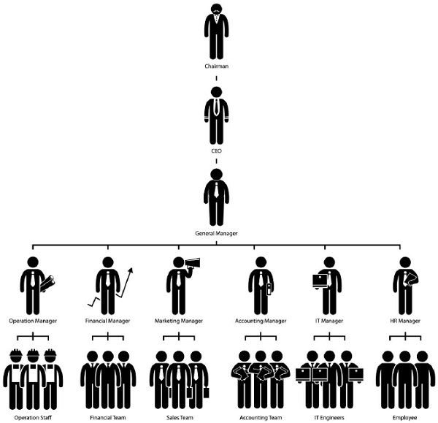

### Initial Division Structures

Initial division structures are common in subsidiaries, export firms, and on-site manufacturers. **Subsidiaries** that follow this kind of organization structure include firms where the main export is expertise, for example, consultants and financial firms. **Export firms** include those having technologically advanced products and manufacturing units. Companies having **on-site manufacturing operations** follow this structure to cut down their costs.

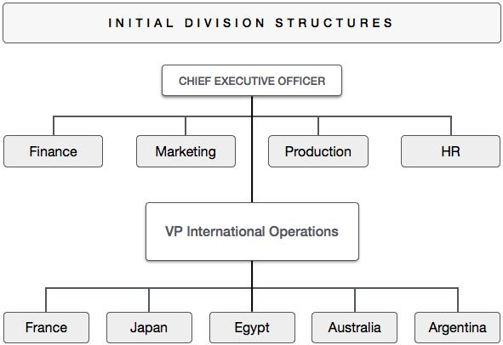

### International Division Structure

This structure is built to handle all international operations by a division created for control. It is often adopted by firms that are still in the development stages of international business operations.

**Advantages**

* International attitude gets the attention of top management
* United approach to international operations

**Disadvantages**

* Separates domestic managers from their international counterparts
* Difficulty in ideating and acting strategically and in allocating resources globally

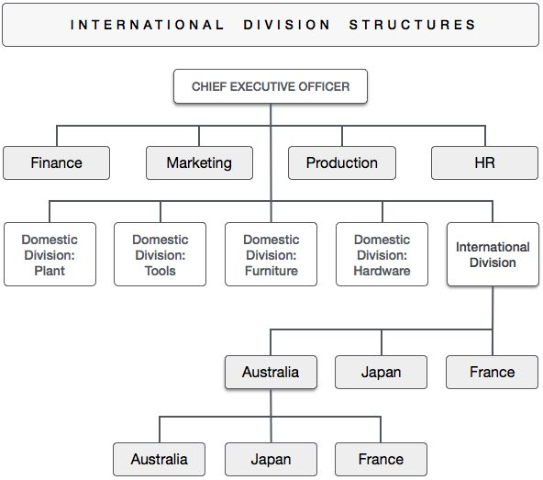

### Global Product Division

Global product divisions include domestic divisions that are allowed to take global responsibility for product groups. These divisions operate as profit centers.

**Advantages**

* Helps manage product, technology, customer diversity
* Ability to cater to local needs
* Marketing, production, and finance gets a coordinated approach on a product-by-product, global basis

**Disadvantages**

* Duplication of facilities and staff personnel within divisions
* Division manager gets attracted to geographic prospects and neglects long-term goals
* Division managers spending huge to tap local, not international markets

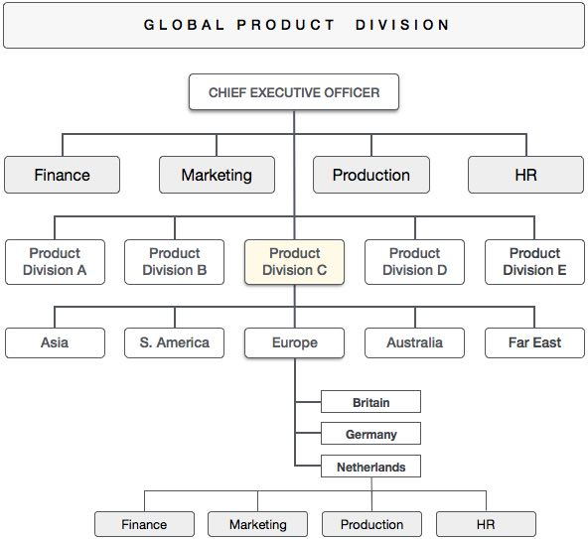

### Global Area Division

Global area division structure is used for operations that are controlled on a geographic rather than a product basis. Firms in mature businesses with select product lines use it.

**Advantages**

* International operations and domestic operations remain at the same level
* Global division managers manage business operations in selected geographic area
* Ability to reduce cost per unit and price competitively

**Disadvantages**

* Difficult to align product emphasis in a geographically oriented manner.
* New R&D efforts are often ignored, as sale in mature market is where the focus is.

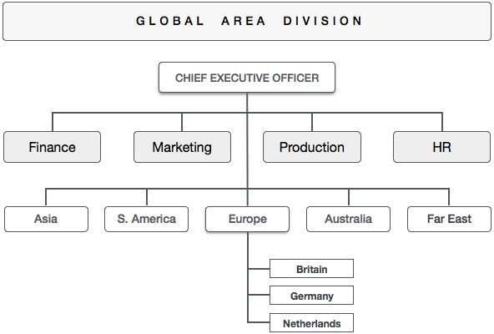

### Global Functional Division

This structure is to primarily organize global operations based on function; product orientation is secondary for firms using global function division structure.

**Advantages**

* It emphasizes on functional leadership, centralized-control, and leaner managerial staff
* Favorable for firms that require a tight, centralized coordination and control over integrated production mechanisms
* Helps those firms that need to transport products and raw materials between geographic areas

**Disadvantages**

* Not suitable for all types of businesses. Applicable to only oil and mining firms
* Difficult to coordinate manufacturing and marketing processes
* Managing multiple product lines can be challenging, as production and marketing are not integrated.

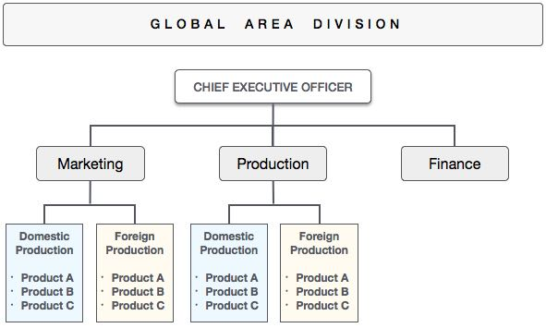

## Mixed Matrix

This structure combines global product, area, and functional arrangements and it has a cross-cutting committee structure.

### Advantages

* Can be designed to meet individual needs
* Promotes an integrated strategic approach tailored to local needs and priorities

### Disadvantages

* Complex structure, coordinating and getting everyone to work toward common goals becomes difficult.
* Too many independent groups in the structure

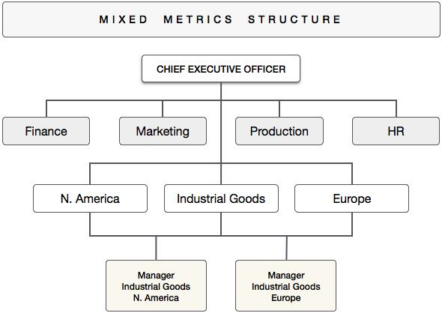

# Control Mechanisms

Control mechanisms play an important role in any business organization, without which the roles of managers get constrained. Control is required for achieving the goals in a predefined manner because it provides the instruments which influence the performance and decision-making process of an organization. Control is in fact concerned with the regulations applied to the activities within an organization to attain expected results in establishing policies, plans, and practices.

Control mechanisms can be set according to functions, product attributes, geographical attributes, and the overall strategic and financial objectives.

## Objectives of Control

There are three major objectives for having a control mechanism in an international firm. They are −

* To get data and clues for the top management for monitoring, evaluating, and adjusting their decisions and operational objectives.
* To get clues based on which common objectives can be set to get optimum coordination among units.
* To evaluate the performance metrics of managers at each level.

In 1916, **Henri Fayol** defined **management control** as follows −

“Control of an undertaking consists of seeing that everything is being carried out in accordance with the plan which has been adopted, the orders which have been given, and the principles which have been laid down. Its object is to point out mistakes in order that they may be rectified and prevented from recurring”

## Types of Control Mechanisms

There are various modes of control. The most influential ones are the following −

### Personal Controls

Personal controls are achieved via personal contact with the subordinates. It is the most widely used type of control mechanism in small firms for providing direct supervision of operational and employee management. Personal control is used to construct relationship processes between managers at different levels of employees in multinational companies. CEOs of international firms may use a set of personal control policies to influence the behavior of the subordinates.

### Bureaucratic Controls

These are associated with the inherent bureaucracy in an international firm. This control mechanism is composed of some system of rules and procedure to direct and influence the actions of sub-units.

The most common example of bureaucratic control is found in case of **capital spending rules** that require top management’s approval when it exceeds a certain limit.

### Output Controls

Output Controls are used to set goals for the subsidiaries to achieve the targeted outputs in various departments. Output control is an important part of international business management because a company’s efficiency is relative to bureaucratic control.

The major criteria for judging output controls include productivity, profitability, growth, market share, and quality of products.

### Cultural Controls

Corporate culture is a key for deriving maximum output and profitability and hence cultural control is a very important attribute to measure the overall efficiency of a firm. It takes form when employees of the firm try to adopt the norms and values preached by the firm.

Employees usually tend to control their own behavior following the cultural control norms of the firm. Hence, it reduces the dependence on direct supervision when applied well. In a firm with a strong culture, self-control flourishes automatically, which in turn reduces the need for other types of control mechanisms.

## Approaches to Control Mechanisms

There are seven major approaches for controlling a business organization. These are discussed below −

### Market Approach

The market approach says that the external market forces shape the control mechanism and the behavior of the management within the organizational units of an MNC. Market approach is applied in any organization having a decentralized culture. In such organizations, transfer prices are negotiated openly and freely. The decision-making process in this approach is largely directed and governed by the market forces.

### Rules Approach

The rules approach applies to a rules-oriented organization where a greater part of decision-making is applied to strongly impose the organizational rules and procedures. It requires highly developed plan and budget systems with extensive formal reporting. Rules approach of control utilizes both the input and output controls in an organized and exclusively formalized manner.

### Corporate Culture Approach

In organizations that follow the corporate culture approach, the employees internalize the goals by building a strong set of values. This value-syndication influences the operational mechanism of the organization. It has been observed that even when some organizations have strong norms of behavioural controls, they are informal and less explicit. Corporate culture approach requires more time to bring the aimed changes or adjustments in an organization.

### Reporting Culture

Reporting culture is a powerful control mechanism. It is used while allocating resources or while the top management wants to monitor the performance of the firm and the employees. Rewarding the personnel is a common practice in such approaches of control. However, to get the maximum out of reporting approach, the reports must be frequent, correct, and useful.

### Visits to Subsidiaries

Visiting the subsidiaries is a common control approach. The disadvantage is that all the information cannot be exchanged via visits. Corporate staff usually and frequently visit subsidiaries to confer and socialize with the local management. Visits can enable the visitors to collect information about the firm which allows them to offer advice and directives.

### Management Performance Evaluation

Management performance Evaluation is used to evaluate the subsidiary managers for the subsidiary’s performance. However, as decision-making authority is different from the operational managers, some aspects of control cannot be managed via this approach. Slow growth rates of firms and risky economical and political environment requires this kind of approach.

### Cost and Accounting Comparisons

Cost and Accounting Comparisons is a financial approach. It arises due to the difference in expenditure among various units of the subsidiaries. A meaningful comparison of the operating performances of the units is necessary to get the full output from this approach. Cost accounting comparisons use a set of rules that are applicable to the home country principles to meet local reporting requirements.

## Constraints of Control Approaches

Control mechanisms can never be uniform in every country. International firms have to face severe constraints based on which they modify their control mechanisms in every country. Here is a list of major constraints that affect an organization in setting its managerial control mechanism −

* **Distance** − Geographical distances and various forms of cultural disparities is a big constraint of control systems. Nowadays, email and fax transmissions have replaced the human communication, changing the meaning of distance among units and employees of an organization.
* **Diversity** − It is hard to apply a common control system to everyone due to diversity. It requires the managers to be locally responsive to address the needs of the country in which the firm operates. Diverse attributes may exist in the form of labor, cost, currency, economic factors, business standards, etc.
* **Degree of Uncertainty** − Data relating to the reporting mechanism may be inaccurate and incomplete, raising serious challenges to control mechanisms. Due to uncertainities, control mechanisms must focus on setting goals and developing plans to meet the goa

# Performance Issues

It is an important part of every business organization to measure the performance of both employees and the firm as a whole. We will, however, restrict our focus on organizational performance measurement. The standard process of measuring the performance of a global business is as shown in the following diagram −

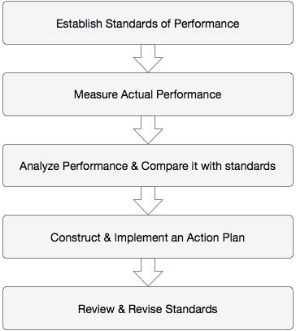

The prominent features of each stage are discussed below.

### Establish Standard of Performance

Standard of performance is applicable to cost, quality, and customer service. More than one standard may be necessary because they reflect expected levels of various units of the manufacturing performance. This includes process yields, product quality, overhead spending levels, etc.

### Measure Actual Performance

To measure actual performance, the use of automated data collection systems is suggested to gather information. A standard cost measurement system includes man-hours, machine-hours, and material usage.

### Analyze the Performance and Compare it with standards

There must be some set standards to compare the actual performance. The standards should be realistic and achievable. The results of the comparison can be used to apply further rules, targets, and reporting.

### Construct and Implement an Action Plan

Constructing and implementing an action plan is key to success. **Variance analysis** can be used to detect potential problem areas. Finding the source of the problem and improving the situation may be useful. Its effectiveness depends on the management’s adaptability to the information obtained.

### Review and Revise Standards

**Review and revise** is an important step, as modern organizations are in a constant state of change. If the variances are significant, the performance standards can be adjusted. Effective Performance Measurement must be integrated with the overall strategy. This step requires various financial and non-financial indicators.

## Effective Performance Measurement System

For getting an effective performance measurement system −

* The measurement objectives must be owned and supported throughout the organization.
* The process must be applied top-down for maximum benefits. The measures applied must be fair and achievable.
* The measurement system and the reporting structure must be simple, clear, and recognizable.
* The firms need to prioritize and focus to address only the key performance indicators.

## Performance Evaluation System

A performance evaluation system must contain periodic review of operations so that the objectives of the firm are accomplished. It is important to have the accounting information to evaluate domestic and foreign operations’ costs and profitabilities.

It is not all that simple to measure the performance of an individual, a division, a subsidiary, or even a company as a whole. It is a lengthy and hectic process. The objectives of performance evaluation are to −

* Find the economic performance of the firm
* Analyze each unit’s management performance
* Monitor the progress of objectives, including the strategic goals
* Assist in appropriate allocation of resources

## Financial and Non-Financial Measures of Evaluation

**ROI (Return on Investment)** − ROI is the most common method to evaluate the performance of an international firm. It shows the relationship between profit to invested capital and encompasses almost all important factors related to performance. An improved ROI can act as a logical motivator of the managers.

**Budget as Success Indicator** − Budget is an accepted tool for measuring and controlling the operations. It is also used to forecast future operations. A budget is a clearly expressed set of objectives that guide the managers to set their individual performance standards. A good local or regional budget helps the company to facilitate its strategic planning process smoothly.

**Non-Financial Measures** − The major non-financial measures that can be used to evaluate performance are − Market Share, Exchange Variations, Quality Control, Productivity Improvement, and Percentage of Sales.

## Types of Performance Evaluation Systems

Performance evaluation systems can be of the following types −

* **Budget Programming** − Budget programming is prepared for operational planning and financial control. It is an easy-to-calculate system to evaluate the variance. It is used to measure the current performance in relation to some comparable performance metric from the past.
* **Management Audit** − It is an extended form of financial audit system which monitors the quality of management decisions in financial operations. It is used for appraisal and performing audit for management.
* **Programme Evaluation Review Technique (PERT)** − Based on CPM, PERT delineates a given project or program into network of activities or sub-activities. The goal is to optimize the time spent by the managers. In this process, performance is measured by comparing the scheduled time and the cost allocated with the actual time and the cost.
* **Management Information System (MIS)** − MIS is an ongoing system designed to plan, monitor, control, appraise, and redirect the management towards pre-defined targets and goals. It is a universally acceptable practice which encompasses the financial, budgeting, audit and control systems of the PERT.

# Production Issues

Production is the core of any business organization having its operations on an international scale. International business firms must look closely at production factors for profitability and sustainability. Production refers to manufacturing, acquiring, and developing products for the business market.

Factors that Affect Production

There are three major areas an international organization must focus on in order to increase its production efficiency. They are −

* Facility Location
* Scale of Operation
* Cost of Production

We will look into each of them in the following sections.

Facility Location

Facility Location refers to the appropriate location for the manufacturing facility; it should have optimum access to customers, workers, transportation, etc.

The main goal of an organization is to satisfy and delight customers with its product and services. The manufacturing unit plays a major role in this direction. One of the most important factors for determining the success of a manufacturing unit is its location.

To get commercial success and retain its competitive advantage, any international business firm would pay attention to the following critical factors while choosing its business location −

* **Customer Proximity** − Customer proximity is important to reduce transportation cost and time.
* **Business Area** − Having other manufacturing units of similar products around the business area is conducive for facility establishment.
* **Availability of Skilled labor** − There should be skilled labor available in and around the facility location.
* **Free Trade Zone** − Free-trade zones usually promote and augment the establishment of manufacturing facility by offering incentives in custom duties and applicable levies.
* **Suppliers** − Continuous availability and quality supply of the raw materials influences in determining the location of production facility.
* **Environmental Policy** − As pollution control is very important, understanding of environmental policy for the facility location is critical.

Scale of Operations

Scale is the synonym for size in business. Business organizations can leverage on their size by making dealings, favorable terms, and volume-discounts with other firms.

**Operating the business at scale** means allocating and optimizing resources to get the greatest results and volume in all market segments. It is linked with optimization, not duplication, of efforts. Keeping costs under control while increasing the sales offers the opportunity for reducing costs and acquiring new customers, and more market share, without lowering the average margin (economies of scale).

**Small-Scale Business** − Also termed a small business, a small-scale business employs a small number of workers and does not have a high volume of sales. The U.S. Small Business Administration states that small-scale businesses have fewer than 500 employees. Financially, a non-manufacturing small-scale business is one that earns below or equal to $7 million a year.

**Large-Scale Business** − Based on the home country and the industry, a small-scale company usually employs between 250 and 1,500 people. Anything above that is a large-scale company.

**Economies of Scale** − It refers to the cost advantages that a business obtains due to its size, output, or scale of operation. Usually, cost per unit generally decreases with the increasing scale, as fixed costs are spread out over more products.

Cost of Production

It is a cost incurred by a company in manufacturing a product or delivering a service. Production costs depend on raw material and labor. To determine the cost of production per unit, the cost of production is divided by the total number of units produced. It is important to know the cost of production to better price an item or a service and to decide its total cost to the company.

Cost of production includes both Fixed and Variable Costs.

* **Fixed costs** do not change with the level of output. They usually include rents, insurance, depreciation, and set-up costs. Fixed costs are also known as **overhead** cost.
* **Variable** costs refer to those costs which vary with the level of output, and are also known as **direct costs** or **avoidable costs**. Examples include fuel, raw materials, and labor costs.

Make-or-Buy Decisions

Make-or-buy decisions are taken to arrive at a strategic choice between manufacturing an item internally (in-house) or buying it externally (from an external supplier). The buy side of the decision is also known as **outsourcing**. Make-or-buy decisions of a firm is important when it has developed a product or part – or significantly modified a product or part – but is having problems with the current suppliers, or has decreasing capacity or changing demand.

The major reasons for manufacturing an item in house includes the following −

* Cost attributes (less expensive to make)
* Intentions to integrate the operations
* Productive use of excess plant capacity (using present idle capacity)
* For direct control over production / quality
* When design secrecy is applicable to protect proprietary technology
* Unreliable / incompetent suppliers
* Very small quantity of production
* Controlling lead time, transportation, warehousing costs
* Political, social, or environmental pressure

Buy decisions are applicable under the following conditions −

* Insufficient local expertise
* Cost considerations (less expensive)
* Small-volume requirements
* Limited production or insufficient capacity
* Intentions to maintain a multiple-source policy
* Indirect managerial control factors
* Procurement and inventory factors
* Brand preference

# Supply Chain Issues

Globalization is changing the way the international firms used to deal with their supply chain networks. This is happening because companies are actively seeking to compete and gain market share. Global companies nowadays manage multiple supply chains, not only to deliver goods on time, but to meet diverse customer and supplier wants related with pricing and packaging. Personalizing the offerings for various customer clusters is necessary to address these issues.

Volatility of markets, economic contractions and mediocre recovery cycles influence distribution, manufacturing, invoicing and sourcing. Reaching out to encompass new markets brings complex taxation, invoicing and localization burdens. Moreover, dispersed segments of markets ask for different pricing models and services. Hence, optimizing the supply chain is necessary to stay competitive.

## Globalization and its Effect on Supply Chain

Many businesses tend to apply outdated processes and technologies to global supply chain operations. Many times, available systems are not compatible with the modern demands. Lack of understanding of current situations and contemporary supply chain can be disastrous. It can result in a rise in costs and decreased efficiency. With the expansion of logistics, the ability to quickly estimate the cost and service implications must increase.

An optimized global supply chain can help a company in the following areas −

* **Reduced Costs** − Companies accessing information relating to suppliers make better procurement decisions. Online supplier and buyer community management can reduce supplier sourcing and procurement costs.
* **Increased Transparency** − Being a single point of access for supplier information as well as buyer-supplier communities is important. International supply chain operators can locate reliable suppliers regardless of location preferences with a global approach and transparent policy.
* **Lower Risk** − An optimized supply chain lets the supplier meet financial, legal, safety, quality, and environmental regulations. As the regulations differ widely, flexibility becomes the key to risk management.
* **Support Legacy & New Products** − Contemporary global supply chains require a billing partner and a supplier settlement platform. The platform needs to take care of taxation, invoicing and other crucial functions. It must encompass multiple fluid business-models to let the company reach international markets.
* **Solutions to Global Supply Chain Challenges** − While looking for growth and quick expansion, companies must consider deeply about what their current supply chains are capable of. They must assess whether their capabilities are enough to meet global competition. In order to support the existing and future business objectives, companies must reconsider the management processes and implement best practices which are more flexible.

# Global Marketing Mix

Global Marketing combines the promotion and selling of goods and services with an increasingly interdependent and integrated global economy. It makes the companies stateless and without walls.

The **4P's** of Marketing − **product, price, place, and promotion** − pose many challenges when applied to global marketing. We take each one of the **P’s** individually and try to find out the issues related with them.

## Global Marketing Mix: Consumer Products

The product and service mix is one of the most important ingredients for the global marketer today. The diverse demand for products and services in the era of globalization is mind-blowing. Presence of industrialized and emerging markets, increasing purchasing power, and the growth of Internet has made the customers aware, smart, and more demanding. The result is a greater competition between firms.

Here are the important factors to consider when going global with a product or service.

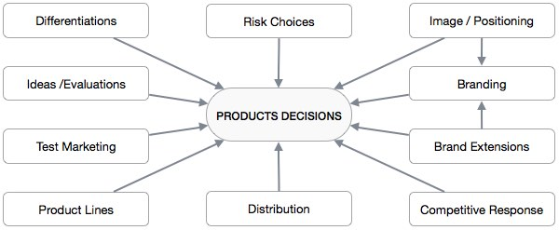

The global consumer makes purchasing decisions to get the best quality products at the most affordable price. They have information available in abundance, thanks to the Internet. Therefore, **innovation** takes center-stage to gain adequate attention from potential consumers.

A global marketer must be **flexible enough to modify the attributes** of its products in order to adapt to the legal, economic, political, technological or climatic needs of a local market. Overall, global marketing requires the firms to have available and specific processes for product adaptation for success in new markets.

**Culture** can differentiate a standardized product from an adapted one. Making cultural changes in product attributes is like introducing a new product in your home country. The product should meet the needs, tastes, and patterns that are permitted by the market culture.

Lastly, it is essential to understand that a product or service is not just one "thing." It should be seen as a part of the whole marketing mix so that a great synergy can be built among different strategies and actions.

## Global Marketing Mix: Price

Pricing is a crucial part of the marketing mix for international firms. Pricing techniques play a critical role when a company wants to penetrate into a market and expand its operations.

### Drivers in Foreign Market Pricing

The most important factors that decide the prices are labelled the **4 C’s** −

* Company (costs, company goals)
* Customers (price sensitivity, segments, consumer preferences)
* Competition (market structure and intensity of competition)
* Channels (of distribution)

### International Pricing Challenges

Global firms face the following challenges while pricing their products and services to suit the requirements of international market −

* **Export Price Escalation** − Exporting includes more steps and higher risks than domestic sale. To make up for shipping, insurance and tariffs, and foreign retail prices, the export price may be much higher than domestic country. It is important to know whether external customers are willing to pay an additional price for the products/services and whether the pricing will be competitive in that market. If both answers are negative, then there are two approaches. One is to find a way to decrease the export price, and the second is to position the product as an exclusive or premium brand.
* **Inflation** − Intense and uncontrolled inflation can be a huge obstacle for MNCs. If inflation rates are rampant, setting prices and controlling costs require full dedication of marketing and financial divisions. Some alternatives to counter inflation include changing the components of products or their packaging, procuring raw materials from low-cost suppliers and shortening credit terms, etc.
* **Currency Movements** − Exchange rates being unstable, setting a price strategy that can get rid of fluctuations gets difficult. Key considerations include what proportion of exchange rate gain or loss should be transferred to customers (the pass-through issue), and finding which currency price quotes are given in.
* **Transfer Pricing** − Transfer prices are the charges for transactions that involve trade of raw materials, components, finished products, or services. Transfer pricing include stakeholders, such as the company, local managers, host governments, domestic governments, and joint-venture partners. Tax regimes, local conditions, imperfections, joint venture partners and the morale of managers affect transfer pricing.
* **Anti-dumping Regulations** − Dumping occurs when imports are sold at an unfair and very low price. Recently countries have adopted anti-dumping laws to protect their local industries. Anti-dumping laws should be considered when deciding global prices.
* **Price Coordination** − Price coordination is the relationship between prices charged in different countries. It is an important consideration while deciding the global pricing model. Price coordination includes the following factors − Nature of customers, Product differentiation amount, Nature of distribution channels, Competition type, Market Integration, Internal organizational characteristics, and Government regulations.
* **Countertrade** − Countertrades are unconventional trade-financing transactions including non-cash compensation. A monetary valuation can however be used in countertrade for accounting purposes. In dealings between sovereign states, the term bilateral trade is generally used. Examples include clearing arrangements, buybacks, counter purchases, switch trading, and offsets.

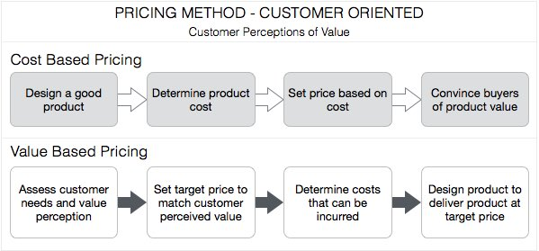

## Global Marketing Mix: Promotion

Promotion comes into picture when a global company wants to communicate its offering to potential customers. How an organization chooses to promote its products and services can have a direct and substantial impact on its sales.

### Advertising and Culture

Advertising can create a popular culture and a culture may influence the ad as well. Culture’s impact in advertising is prevalent, especially in culturally-sensitive issues like religion and politics.

**Cultural Effect**

Procter & Gamble had problems advertising the Pert Plus shampoo in Saudi Arabia, where only veiled women can be shown in TV commercials. The company had to show the face of a veiled woman, and the hair of another from the back.

### Setting a Budget

A global marketer can consider budgeting rules such as percentage of sales (creating budget as a percentage of sales revenues), competitive parity (taking competitor’s ad spending as a benchmark), or objective-and-task (treating promotional efforts to achieve stated objectives). Global markets use **three approaches** to reach allocation decisions −

* In **bottom-up budgeting,** the units independently determine the market budget and request resources from headquarters.
* In **top-down budgeting,** the headquarters set a total budget and split up the resources.
* Decisions may also be made at a **regional level** and submitted to the headquarters for their approval.

### Promotional Strategy

When global marketers choose a standardized approach, the same global campaign is applied throughout all countries.

* **Advantages** − Achieving economies of scale in ad campaigns to reduce cost, maintaining a consistent brand image.
* **Barriers** − Cultural differences resulting in negative or ineffective consumer response, advertising laws and regulations, variations in degree of marketing development.

**The NIH Syndrome: A Barrier to Standardized Approach**

“Not Invented Here” syndrome occurs when agencies or business subsidiaries reject using a standardized campaign simply because they did not invent or come up with the campaign.

### Assessing Global Media Decisions

Global media decisions are a big concern for global firms. The media buying patterns vary across countries. A global marketer must find the best media channels in a market.

### Ad Regulations

Foreign regulations on advertisements may be present in a specific country. Research of the laws in the country of operation is necessary before developing a campaign, to avoid legal implications and waste of time and money.

### Choosing an Agency

Choosing an ad agency may prove more effective due to their understanding of the country and market they are doing business in.

### Other Communication Options

Sales events, direct marketing, sponsorships, mobile marketing, product placement, viral marketing, and public relations and publicity are also applicable.

### Globally Integrated Marketing Communications (GIMC)

A GIMC is a system of promotional management that coordinates global communications - horizontally (from country to country) and vertically (promotion tools). GIMC is meant to harmonize the promotional and communication disciplines in every way. All communication vehicles may be integrated so that they convey the single idea to all concerned in a unified voice.

## Global Marketing Mix: Distribution

In order to be successful in a global market, a marketer must make its products and accessible to customers at all costs. Distribution channels make up the "place" in the 4 P’s of the marketing mix (along with Product, Price, and Promotion).

### Distribution Processes and Structures

The distribution process deals with product handling and distribution, the passage of ownership (title), and the buy and sell negotiations.

Negotiations take place between the producers and the middlemen and then between the middlemen and the customers.

Traditionally, **import-oriented distribution** structures relied on a system where importers controlled a fixed supply of goods. The marketing was based on the idea of limited suppliers, high prices, and smaller number of customers. Today, the import-oriented model is hardly used. Channel structures have become more advanced with overall development.

### Distribution Patterns

To understand a foreign distribution system, marketers should never believe that it is the same as the domestic one. Many distribution patterns exist in retailing and wholesaling. Size, patterns, direct marketing, and the resistance to change affect the composure of distribution channels.

* **Retail size and pattern** − Company’s may either sell to large, dominant retailers directly or distribute to smaller retailers.
* **Direct marketing** − The challenge in underdeveloped nations is handled through direct marketing. Direct marketing occurs when consumers are targeted through mail, telephone, email, or door-to-door selling. This process also doesn’t take retailer and wholesaler types into consideration.

### Choosing Your Middleman

The channel process starts with manufacturing and ends with the final sale to the customer. It is most likely to counter many different middlemen in the process. There are three types of middlemen in distribution channels −

* **Home-Country Middlemen** − They provide marketing and distribution services from a domestic base in the home country. The parties usually relegate the foreign-market distribution to others; including manufacturer or global retailers, export management companies, or trading companies.
* **Foreign-Country Middlemen** − For a greater control, foreign-country middlemen are hired who can create a shorter channel and have more market expertise.
* **Government-Affiliated Middlemen** − Government-affiliated middlemen are often responsible in distribution for the government’s use.

### Factors Affecting Choice of Channels

Channel of distribution or middlemen selection must precede the understanding of the characteristics of the foreign market and the established common system there. The major factors to consider while choosing a particular channel are −

* The specific target market within and across countries.
* The goals in terms of volume, market share, and profit margin.
* The financial and organizational commitments.
* Control of the length and characteristics of the channels.

## Application of 4 P’s

The following illustration depicts the global marketing mix of McDonald’s. It shows how McDonald’s varies its marketing strategy according to the requirements of different local markets.

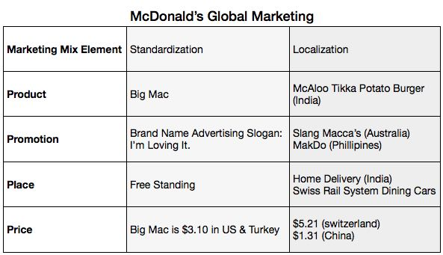

# Financial Aspects

Foreign Investment by International Companies

The proliferation of MNCs began 200 years back, but then, foreign investments were quite limited. Investments were made through portfolio and long-term Greenfield or joint venture investments were low. Globalization, however, has led MNCs to become more dominant players in the global economy.

The end of the cold war that brought the idea of liberalization of the developing markets and opening of their economies has played a major role in international investments. With the vanishing of foreign investment barriers, privatization of the state economic organizations and development of FDI policies, MNCs have started investing aggressively.

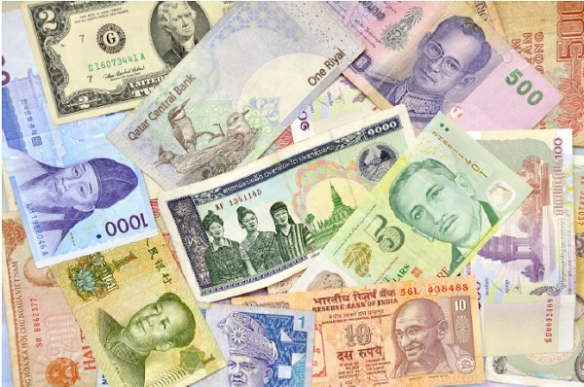

FDI has become by far the single largest component of the net capital inflows. It also has effects on the human capital of the economies. Countries benefit substantially from the investment. Investments in developing countries have integrated the developing economies with other countries of the world. This is often referred to as economic openness.

**Note** − Seventy percent of world trade is controlled by just 500 of the largest industrial corporations. In 2002, the combined sales volume of the top 200 companies was equivalent to 28% of the overall GDP of the world.

International Investment Outcomes

International corporations have shaped the global economy in the 20th century. Now, any of the world’s Top 100 or global companies exceed the GDP of many nations. The MNCs are also creating most of the output and employment opportunities in the world.

The MNCs have started building local relationships and establishing a strong local presence through FDI’s to benefit from different advantages, where the countries focusing on getting more FDI investment have become busy with giving MNCs more freedom and assistance in seeking economic cooperation with them.

As the importance MNCs in the global economy increases, companies have been both criticized and appreciated. The growing shares of MNCs in developing economies and the impact of their decisions in overall economic conditions of the host countries have been under review.

* **Cons** − MNCs are mainly criticized for disappearance of domestic players due to their global brand, use of latest technology, marketing and management skills, and economies of scale which domestic firms cannot compete with. MNCs have also been criticized for controlling the domestic economic policies and taking actions against the developing country’s national interests.
* **Pros** − The investments have brought technological and managerial assets to developing countries. Employment with a better-trained labor force, a higher national income, more innovations, and enhanced competitiveness are some of the positive contributions of MNCs to developing countries.

Factors for Investment Decisions

MNCs want to minimize the cost and maximize their economies of scale. They invest in different locations to operate better in their home base. It motivates firms to expand and invest abroad and become multinational. Looking for new markets, want of cheaper raw materials, and managerial knowledge or technology and cheaper production are the major motivations for global expansion.

International companies want the perfect mix of the factors for finding "where to invest". Labor costs and skill and educational levels of workforce, the purchasing power of the market and proximity to other markets are considered while making an investment decision.

|  |  |
| --- | --- |
| **factors Affecting Investment Decisions** | |
| **Factors** | **Percentage of companies that believe factor is important** |
| Market Opportunity | 100% |
| Patent Protection | 85% |
| Regulatory Environment | 60% |
| Competitor Pressure | 60% |
| Consumer Acceptance | 55% |
| Availability of Skilled labor | 40% |
| Technology Transfer mechanisms | 35% |
| Availability of Equity Capital | 20% |
| Scale and Quality of Public R & D | 15% |
| Access to Innovative Suppliers | 80% |

Funding the International Business

Funding is the act of acquiring resources, either money (financing) or other values such as effort or time (sweat equity), for a project, a person, a business, or any other private or public institution. The soliciting and gathering process of funds is called **fundraising**.

Economically, funds are invested as capital by lenders in the markets and are taken up as loans by borrowers. There are two ways how capital can end up at the borrower

* Lending via a middlemen is an example of **indirect finance**.
* Direct lending to a borrower is called **direct finance**.

An international business depends on its capital structure to find the best debt-to-equity ratio of the funding to maximize value. There must be a balance between the ideal debt-to-equity ranges to minimize the firm's cost of capital. Theoretically, debt financing generally is least costly due to its tax deductibility. However, it is not the optimal structure as a company's risk generally increases as debt increases.

Sources of Funds

* **Export-Import Banks** − These banks provide two types of loans − Direct loans to foreign buyers of exports, and Intermediary loans to responsible parties, such as foreign government-lending agencies which then re-lend to foreign buyers of capital goods and related services.
* **With-in company loans** − New companies raise funds through external sources, such as shares, debentures, loans, public deposits, etc., while an existing firm can generate funds through retained earnings.
* **Eurobonds** − International bonds are denominated in a currency of non-native country where it is issued. This is good in providing capital to MNCs and foreign governments. London is the center of the Eurobond market, but Eurobonds may be traded throughout the world.
* **International equity markets** − International businesses can issue new shares in a foreign market. Shares are the most common tool for raising long-term funds from the market. All companies, except those that are limited by a guarantee, have a statutory right to issue shares.
* **International Finance Corporation** − Loans from specialized financial institutions and development banks or from commercial banks are also tools for generating funds.

Foreign Exchange Risks

There are three types of risks associated with foreign exchange −

* **Transaction risk** − This is the risk of an exchange rate change on transaction date and the subsequent settlement date, i.e., it is the gain or loss arising on conversion.
* **Economic risk** − Transactions depend on relatively short-term cash flow effects. However, economic exposure encompasses the longer-term effects on the market value of a company. Simply put, it is a change in the present value of the future after-tax cash-flows for exchange rate changes.
* **Translation risk** − The financial statements are usually translated into the home currency to consolidate into the group's financial statements. It can pose a challenge when exchange rates change.

Hedging Forex Risks – Internal Techniques

Internal techniques to manage/reduce forex exposure include the following −

* **Invoice in Home Currency** − An easy way is to insist that all foreign customers pay in your home currency and that your company pays for all imports in your home currency.
* **Leading and Lagging** − If an importer (payment) expects that the currency it is due to pay will depreciate, it may attempt to delay payment. This may be achieved by agreement or by exceeding credit terms. If an exporter (receipt) expects that the currency it is due to receive will depreciate over the next three months, it may try to obtain payment immediately. This may be achieved by offering a discount for immediate payment. The problem lies in guessing which way the exchange rate will move.
* **Matching** − If receipts and payments are in the same currency and are due at the same time, matching them against each other is a good policy. However, the only requirement is to deal with the forex markets for the unmatched portion of the total transactions. Also, setting up a foreign currency bank account is an extension of matching.
* **Doing Nothing** − The theory suggests that long-term gains and losses gets hedged automatically. Short-term losses may be significant in such processes. Advantage is the savings in transaction costs.

Hedging Forex Risks – External Techniques

Transaction risks can also be hedged using a range of financial products −

* **Forward Contracts** − The forward market is used to buy and sell a currency, on a fixed date for a rate, i.e., the forward rate of exchange. This effectively fixes the future rate.
* **Money Market Hedges** − The idea is to minimize uncertainty by making the exchange at the current rate. This is done by depositing/borrowing the foreign currency till the real commercial cash flows occur.
* **Futures Contracts** − Futures contracts are standard sized, traded hedging instruments. The aim of a currency futures contract is to fix an exchange rate at some future date, subject to basis risk.
* **Options** − A currency option is a right, but not an obligation, to buy or sell a currency at an exercise price on a future date. The right will only be exercised in the worst-case scenario.
* **Forex Swaps** − In a Forex swap, the parties agree to swap equivalent amounts of currency for a period and then re-swap them at the end of the period at an agreed swap rate. The rate and amount of currency is fixed in advance. Thus, it is called a fixed rate swap.
* **Currency Swaps** − A currency swap lets the parties to swap interest rate commitments on borrowings in different currencies. The swap of interest rates could be fixed.

# HRM Issues

## Recruitment and Selection

**Recruitment** is a process of attracting a pool of qualified applicants. **Selection** is choosing applicants from this pool whose qualifications match the job requirements most closely. Traditionally, there are three types of employees −

* **Parent Country National** − The employee’s citizenship is same with the organization.
* **Host Country National** − The employee is local for the subsidiary.
* **Third Country National** − The employee is from a different country, i.e., not where the organization is registered / based and also where the subsidiary of the organization is not located.

Staffing and managing approaches strongly affect the type of employee the company looks for. In **Ethnocentric approach,** the parent country nationals are chosen for headquarters and subsidiaries. In **polycentric approach,** host country nationals work in the subsidiaries, while parent country nationals are chosen for headquarters. An organization with a **geocentric approach** chooses employees purely based on talent, regardless of their origin type.

A balance between internal organizational consistency and local labor practices policy is a goal during recruitment. People in achievement-oriented nations consider skills, knowledge, and talents while hiring a new employee.

## Development & Training

The overall aim of the development function is to provide adequately trained personnel in a company as well as to contribute to better performance and growth with their work. At the international level, human resource development function manages −

* Training and development for global employees
* Special training to prepare expatriates for international jobs
* Development of globally efficient managers

Creation and transfer of international human resource development programs may be carried out in two ways −

* In **centralized approach,** headquarters develop trainings and trainers travel to subsidiaries, often adapting to local situations. This fits mostly with the ethnocentric model. A geocentric approach is also centralized, but the training inputs come from both headquarters and subsidiaries staff.
* In **decentralized approach,** training is carried out on a local basis, which follows a polycentric model. In decentralized training, the cultural backgrounds of employees and corporate trainers are same. Training material and techniques are usually local and for use in their own area.

## Performance Evaluation

In companies, performance evaluation is most frequently carried out for administration or development purpose.

For administration purposes, performance evaluation is done when the decisions on work conditions of employees, promotions, rewards and/or layoffs are in question. Development intention is oriented to the betterment of work performance of employees, as well as to the enhancement of their abilities. It is also a way for advising employees regarding corporate behavior.

Performance evaluation can be quite challenging, especially when it carried out at an international level. The international organization must evaluate the employees from different countries. Consistency across subsidiaries for performance comparisons with contrasting cultural background makes the evaluation meaningful. As with other functions, the approach to performance evaluation depends on the organization’s overall human resource management strategy.

## Management of Expatriates

Expatriates management is one of the most important issues in international business. The most important issues related to Management of Expatriates are the following −

### The Reasons for Expatriate Failure

In international companies, the high failure rate of expatriates can be contributed to six factors − career blockage, culture shock, lack of cross-cultural training, an overemphasis on technical qualifications, using international assignments to get rid of problematic employees, and family problems.

### Cross-Cultural Adjustment

Expatriates and their families need time to become familiar with their new environment. The **culture shock** occurs when after some time, the expatriates find new job conditions unattractive. It usually takes three to six months after arrival, to get out of the culture shock.

### Expatriate Re-Entry

After the expatriate completes his assignment and returns home, the work, people, and general environment becomes unfamiliar. The expatriate is generally unprepared to deal with **reverse culture shock**.

### Selection of Expatriates

The choice of employee for an international assignment is a critical decision. To choose the best employee for the job, the management should −

* Make cultural sensitivity a selection criterion
* Have expatriates in selection board
* Look for international experience
* Hire foreign-born employees as “expatriates” in future
* Screen spouses and families too

### Expatriate Training

Expatriates when trained to prepare for work abroad are more successful. Lack of training can lead to expatriate failure. **Cross-cultural training** (CCT) is very important. It prepares to live and work in a different culture because coping with a brand new environment can be challenging.

### Expatriate Evaluation and Remuneration

There are three common aspects that determine the remuneration of expatriates. In a **home-based policy,** employees’ remuneration is according to their home countries. The **host-based policy** sets salaries according to the norms of the host country. Finally, region also effects in determining the remunerations.

Remuneration for foreign employees depends on their relocation − whether it is within their home region or in another region. With this approach, closer to home (within the region) jobs fetch lower remuneration than the away (outside the region) jobs.

# Adverse Effects

Although globalization has brought with it a lot of benefits, it can sometimes have adverse effects as well. In this chapter, we will discuss how a country gets adversely affected by allowing multinationals to flourish.

### Adverse Effects on Economy

When two countries get engaged in an international business, one country’s economic condition affects the economy of the other country. Large-scale exports also hamper and discourage the developments in industrialization of the importing country. Therefore, the economy of the importing country may feel the heat.

### Unequal Competition

Due to internationalization, all countries come to a single platform of business. As developing countries cannot compete with the developed ones, the growth and development of the developing nations get affected. If the developing countries do not regulate international business, it may be detrimental for their economies.

### Rivalry among Nations

Globalization has increased the level of competition among countries. Due to intense competition and eagerness to get an upper-hand in exporting more commodities, sometimes the nations may come across unhealthy business circumstances. It may lead to rivalry among nations, diminishing international peace and harmony.

### Colonization

Heavy exporters often undermine the issues of the importing nation. If the importing country depends too much on the imported products, it may turn into a colony. Overt economic and political dependence on the exporting nation coupled with industrial backwardness may harm the importing nation.

### Exploitation

Developed countries, due to their economic prowess, may try to exploit the developing and third-world countries for their business motives. As the prosperous and dominant nations usually tend to regulate the economy of poor nations, international business may lead to exploitation of developing countries by the developed countries.

### Legal Problems

International businesses may also create various legal problems. It is a fact that there are many legal aspects of international business. The international business organizations may sometimes neglect these laws and indulge in illegal activities. Varied legal regulations and customs formalities are followed by different countries. This affects export and import and general trade. Legal problems are common in many nations.

### Negative Publicity

There are many cultural effects of internationalization. A multinational company may not be vigilant enough to pay attention to host country’s cultural, norms. As cultural values and heritages differ among countries, there are many aspects of international organizations, which may not be suitable for the host country. The atmosphere, culture, tradition, etc., get affected due to this.

### Dumping Policy

Dumping is a real danger. As the industrially mature economies can produce and sell the products in cheaper rate than the home country, the products may be dumped in the less developed nations. This creates an unfair competition in the local markets. People often go for the cheaper priced items, being unaware that their own country and the industries may get destroyed due this type of dumping policies.

### Shortage of Goods in the Exporting Country

As exporting brings enough profit, sometimes, traders may prefer to sell their products in a foreign country. The exporters may sell the good quality products in foreign nations even when there is a demand in the local markets. This often results in shortage of quality goods within the home country.

### Adverse Effects on Domestic Industry

International business poses a threat to the survival of small-scale industries. As the big companies have enough muscle power, they do not let the start-ups compete and add value. Due to such kind of unfair foreign competition and unrestricted imports, the start-ups in the home country find it difficult to survive.

# Conflict Management

In this chapter, we will discuss the types of organizational conflicts and how an international business concern manages its internal conflicts.

## Types of Conflicts

Conflicts in an organization can arise due to multiple reasons, based on which they can be categorized into different types.

### On the basis of involvement

Conflicts may be **personal** (intrapersonal and interpersonal) and **organizational**. Organizational conflicts can be **intra-organizational** and **inter-organizational**. Inter-organizational conflicts occur between two or more organizations. Intra-organizational conflicts can be further divided into **intergroup** and **intragroup** conflict.

### On the basis of scope

Conflicts may be substantive and affective. An **affective conflict** deals with interpersonal aspects. **Substantive conflict** is also called performance, task, issue, or active conflict. Procedural conflicts can include disagreements about the process of doing a job.

### On the basis of results

Conflicts can be constructive or destructive, creative or restricting, and positive or negative. **Constructive conflicts** are also known as functional conflicts, because they support the group goals and help in improving performance. **Destructive conflicts** are also known as dysfunctional conflicts, they prevent people from reaching their goals. Destructive conflicts take the attention away from other important activities, and involve negative behaviour and results, such as name-calling.

### On the basis of sharing by groups

Conflicts may be distributive and integrative. **Distributive conflict** is approached as a distribution of a fixed amount of positive outcomes or resources. In an **Integrative conflict,** groups see the conflict as a chance to integrate the needs and concerns of both groups. It has a greater emphasis on compromise.

### On the basis of Strategy

Conflicts may be competitive and cooperative. **Competitive conflict** is accumulative. The original issue that began the conflict becomes irrelevant. Costs do not matter in competitive conflict. A **cooperative conflict** is of interest-based or integrative bargaining mode; it leads the parties involved to find a win-win solution.

### On the basis of rights and interests

If some people are granted certain rights by law, contract, agreement, or established practice and when that right is denied, it leads to a conflict. These conflicts are settled by law or arbitration. In conflict of interests, a person or group may demand some privileges, no law or right being existent. Negotiation or collective bargaining solves this type of conflict.



## Factors Causing Conflicts

In an international business, there can be various factors behind a conflict −

* There can be conflicts over control of resource or area.
* Conflicts can arise over the right to participate in decision-making.
* No clear-cut goals of the organization can lead to conflicts.
* No clear-cut agreements and contracts may lead to a legal mess, causing conflict.
* Misleading communication may confuse and create conflicts.
* Corruption may also create conflicts.

## Conflict Management

Organizations face a great deal of conflict within and externally while doing business. Experts agree that managing conflicts can be actually quite challenging. International businesses use five distinct forms of solutions to solve conflicts. These are − avoidance, accommodation, competition, compromise, and collaboration.

* The **avoidance strategy** tends to ignore the conflict. Therefore, it provides no resolution to the disagreement. The real source of the conflict is never addressed which leaves the situation unresolved. This ultimately drives the organization away from the work at hand and makes the conflict worse than its initial state.
* The **accommodation strategy** believes in handling a problem as quickly as possible. In such a strategy, one party accepts the other’s demands. Since one party usually gets ignored, it causes an ineffective attempt at conflict management. It only shows that the dominant party continues to rule over the compliant party. This strategy leaves the analysis to conclude the reasons and necessity of a mutual resolution.
* **Competition** occurs as both parties attempt to maximize their own agenda. Competition can quickly escalate into greed. It does not offer the parties an opportunity to benefit the organization. This strategy often becomes ineffective since the two parties are more concerned about winning than arriving at the best possible solution.
* **Compromise** is preferably a good strategy, as both parties involved in the process are willing to give and take. They are concerned about their own ambitions, yet at the same time, they pay heed to the objectives of the organization. Each party involved in a compromise fully understands and works for the best interest of the organization.
* The **collaboration strategy** starts with the manager taking a preliminary initiative step in handling the issue already set. Each party wants to solve the problem by cultivating a pleasing solution leading to a win-win situation. The international managers however must understand the “internal environment in which the organization members function” to make use of this strategy. The collaboration strategy is both assertive and cooperation; yet it smoothly takes the different points of view into consideration. Collaboration is the most effective and efficient form of conflict management.

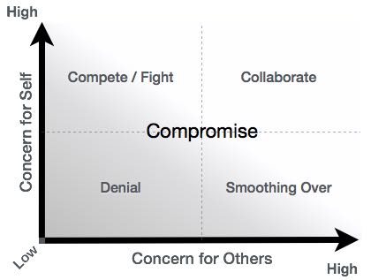

## Five A’s Technique

Borisoff and Victor identify five steps in the conflict management process that they called the "five A's" of conflict management − assessment, acknowledgement, attitude, action, and analysis.

* **Assessment** − In the assessment step, the parties involved collect real information about the problem. The parties involved also choose the appropriate conflict-handling modes and decide the central factors of the problem. They also indicate compromise-able areas, and the wants of each party.
* **Acknowledgement** − The acknowledgement step allows each party to hear out the other and both parties to build the empathy needed for the solution. Acknowledgement is more than just responding; it involves actively encouraging the other party to communicate.
* **Attitude** − In the attitude step, parties try to remove pseudo-conflict issues. Stereotypes of different, culturally-based behaviours are unearthed. Similarly, differences in communication of men and women are accepted. Generally, we can analyze problems from the styles of writing, speaking, and other nonverbal cues.
* **Action** − This step includes implementation of the chosen conflict-handling mode. Each individual evaluates the opposite party’s behavior to ascertain potential trouble spots. Also, each individual stays aware of his own communication style and general behavior. Finally, all parties become alert to new issues and look for productive solutions.
* **Analysis** − In this last step, participants decide on actions, and find the gist of what they have agreed upon. The analysis step initiates the impetus for approaching conflict management as an ongoing process.

# Negotiations

International negotiations need the parties to follow legal, procedural, and political regulations of more than one nation. These laws and procedures are often inconsistent, or even directly opposing in nature. International business agreements should look into these differences. Arbitration clauses, specification of the governing laws, and tax havens should be well defined in the agreements. We have listed here the most common attributes and elements that must be taken into account while doing international negotiations.

* The presence of different currencies should be taken into account. As the relative value of different currencies is not fixed, the actual value prices may vary, and result in unanticipated losses or gains.
* Each government tends to control the flow of its domestic and foreign currencies. Therefore, business deals should look for the governmental willingness to make its currency available. Some policies of government may be detrimental as well.
* Governments often play a significant role in foreign business. Extensive government bureaucracies can affect the negotiation process. Legal complications may also set in.
* International ventures are vulnerable to political and economic risks. These risks require the negotiator to have knowledge and social insight.
* Different countries have different ideologies about private investment, profit, and individual rights. Effective negotiators will have to present ideologically acceptable proposals to the other.
* Finally, cultural differences, such as language and values, perceptions, and philosophies may result in very different connotations according to culture and norms. The international negotiator must be aware of this.

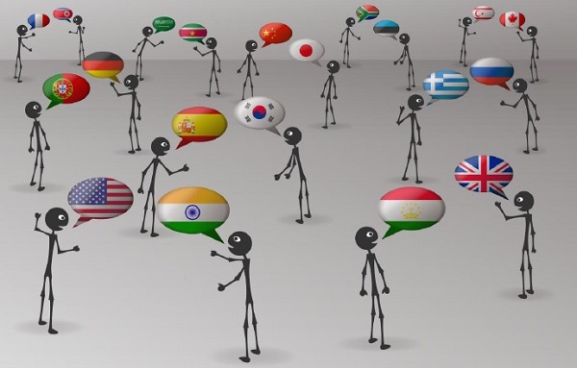

## Role of International Agencies in Negotiations

The role of international agencies in the negotiation process is indispensable. The agencies play a key role in finding an amicable and mutually beneficial negotiation. Organizations like the WTO have a big role in making the MNCs find a good solution to their international disputes. The requirement of such agencies become critical mainly in three areas.

### When the business is unfamiliar with the issues and rules at hand

In many cases, business negotiations occur in a situation and place that is unfamiliar to the organization. These negotiations lead the managers out of their comfort zone and into unfamiliar territory. Often, the managers may not be quite knowledgeable in legal and cultural matters.

In such situations, the international agencies can play a big role. If the organizations’ managers are unsure of the issues under discussion or do not know the perfect rules of the game, an agency may be quite helpful in offering a helping hand.

### When issues of time or distance present in the process

If the negotiation process takes place in an unfamiliar territory, the customs and rules are generally unknown to the key managerial decision makers. In this case, an international agency may be handy.

This also applies when the managers of an organization are under a tight deadline. When these managers don’t have the time and resources to meet with the other parties in a distant location or cannot participate in all steps in the process, they are quite unlikely to represent themselves well. In this situation also, an international agency may fill the gap.

### When there is a poor relationship with the negotiating partner

If the organization is dreading to have negotiations with a party they had clashed earlier, then an international agency may play a key role. The agency may calm both the parties and ensure that the business negotiation remains a matter of business.

This is a good strategy in case of contentious diplomatic contexts, such as the negotiation of a cease-fire between warring armies. In the business world, if the rancour between a company and another over a business contract is deep-seated and ongoing, both sides may get benefits by employing experienced agents to move the negotiation process forward.

If the business thinks that they won’t be able to pursue their business interests effectively – especially when there are chances of aggressive behavior on the other side, an international agency may bridge the gap in finding an amicable and win-win negotiation.

# Ethical Issues

As political, legal, economic, and cultural norms vary from nation to nation, various ethical issues rise with them. A normal practice may be ethical in one country but unethical in another. Multinational managers need to be sensitive to these varying differences and able to choose an ethical action accordingly.

In an international business, the most important ethical issues involve employment practices, human rights, environmental norms, corruption, and the moral obligation of international corporations.

## Employment Practices and Ethics

Ethical issues may be related to employment practices in many nations. The conditions in a host country may be much inferior to those in a multinational’s home nation. Many may suggest that pay and work conditions need to be similar across nations, but no one actually cares about the quantum of this divergence.

12-hour workdays, minimal pay, and indifference in protecting workers from toxic chemicals are common in some developing nations. Is it fine for a multinational to fall prey to the same practice when they chose such developing nations as their host countries? The answers to these questions may seem to be easy, but in practice, they really create huge dilemmas.

## Human Rights

Basic human rights are still denied in many nations. Freedom of speech, association, assembly, movement, freedom from political repression, etc. are not universally accepted.

South Africa during the days of white rule and apartheid is an example. It lasted till 1994. The system practiced denial of basic political rights to the majority non-white population of South Africa, segregation between whites and nonwhites was prevalent, some occupations were exclusively reserved for whites, etc. Despite the odious nature of this system, Western businesses operated in South Africa. This unequal consideration depending on ethnicity was questioned right from 1980s. It is still a major ethical issue in international business.

## Environmental Pollution

When environmental regulation in the host nation is much inferior to those in the home nation, ethical issues may arise. Many nations have firm regulations regarding the emission of pollutants, the dumping and use of toxic materials, and so on. Developing nations may not be so strict, and according to critics, it results in much increased levels of pollution from the operations of multinationals in host nations.

Is it fine for multinational firms to pollute the developing host nations? It does not seem to be ethical. What is the appropriate and morally correct thing to do in such circumstances? Should MNCs be allowed to pollute the host countries for their economic advantage, or the MNCs should make sure that foreign subsidiaries follow the same standards as set in their home countries? These issues are not old; they are still very much contemporary.

## Corruption

Corruption is an issue in every society in history, and it continues to be so even today. Corrupt government officials are everywhere. International businesses often seem to gain and have gained financial and business advantages by bribing those officials, which is clearly unethical.

**Corruption in Japan**

In the 1970s, Carl Kotchian, an American business executive who served as the president of **Lockheed Corporation**, paid $12.5 million to Japanese agents and government officials to sell Lockheed’s TriStar jet to **All Nippon Airways**. After the case was discovered, U.S. officials charged Lockheed with falsification of its records and tax violations.

The revelations created a scandal in Japan as well. The ministers who took the bribe were charged, and one committed suicide. It even led to the jailing of Japan’s prime minister. The Japanese government fell in disgrace, and the Japanese citizens were outraged. Kotchian had, without doubt, engaged in unethical behavior.

## Moral Obligations

Some of the modern philosophers argue that the power of MNCs brings with it the social responsibility to give resources back to the societies. The idea of Social Responsibility arises due to the philosophy that business people should consider the social consequences of their actions.

They should also care that decisions should have both meaningful and ethical economic and social consequences. Social responsibility can be supported because it is the correct and appropriate way for a business to behave. Businesses, particularly the large and very successful ones, need to recognize their social and moral obligations and give resources and donations back to the societies.